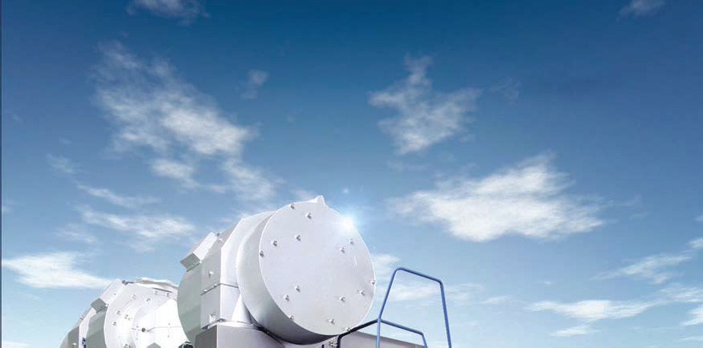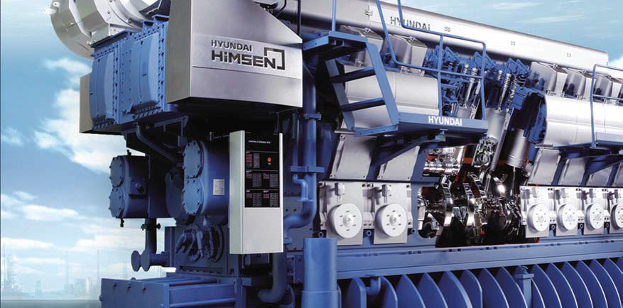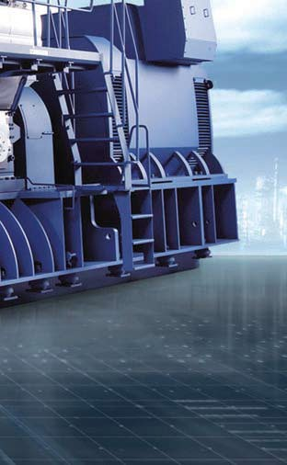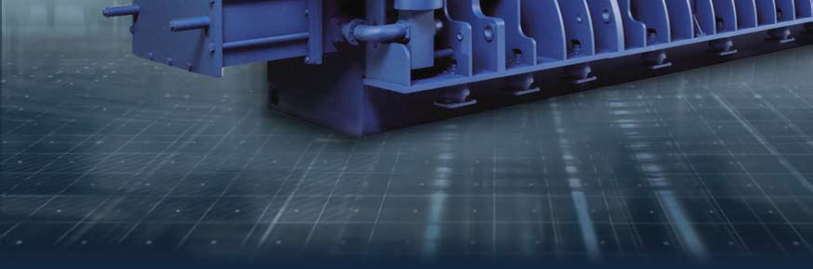

ENGINE &
MACHINERY DIVISION
HHI-EMD

Hi-OPTIMIZED POWER SOLUTIONS
Power + Passion Smart + Optimization Eco + Sustainability

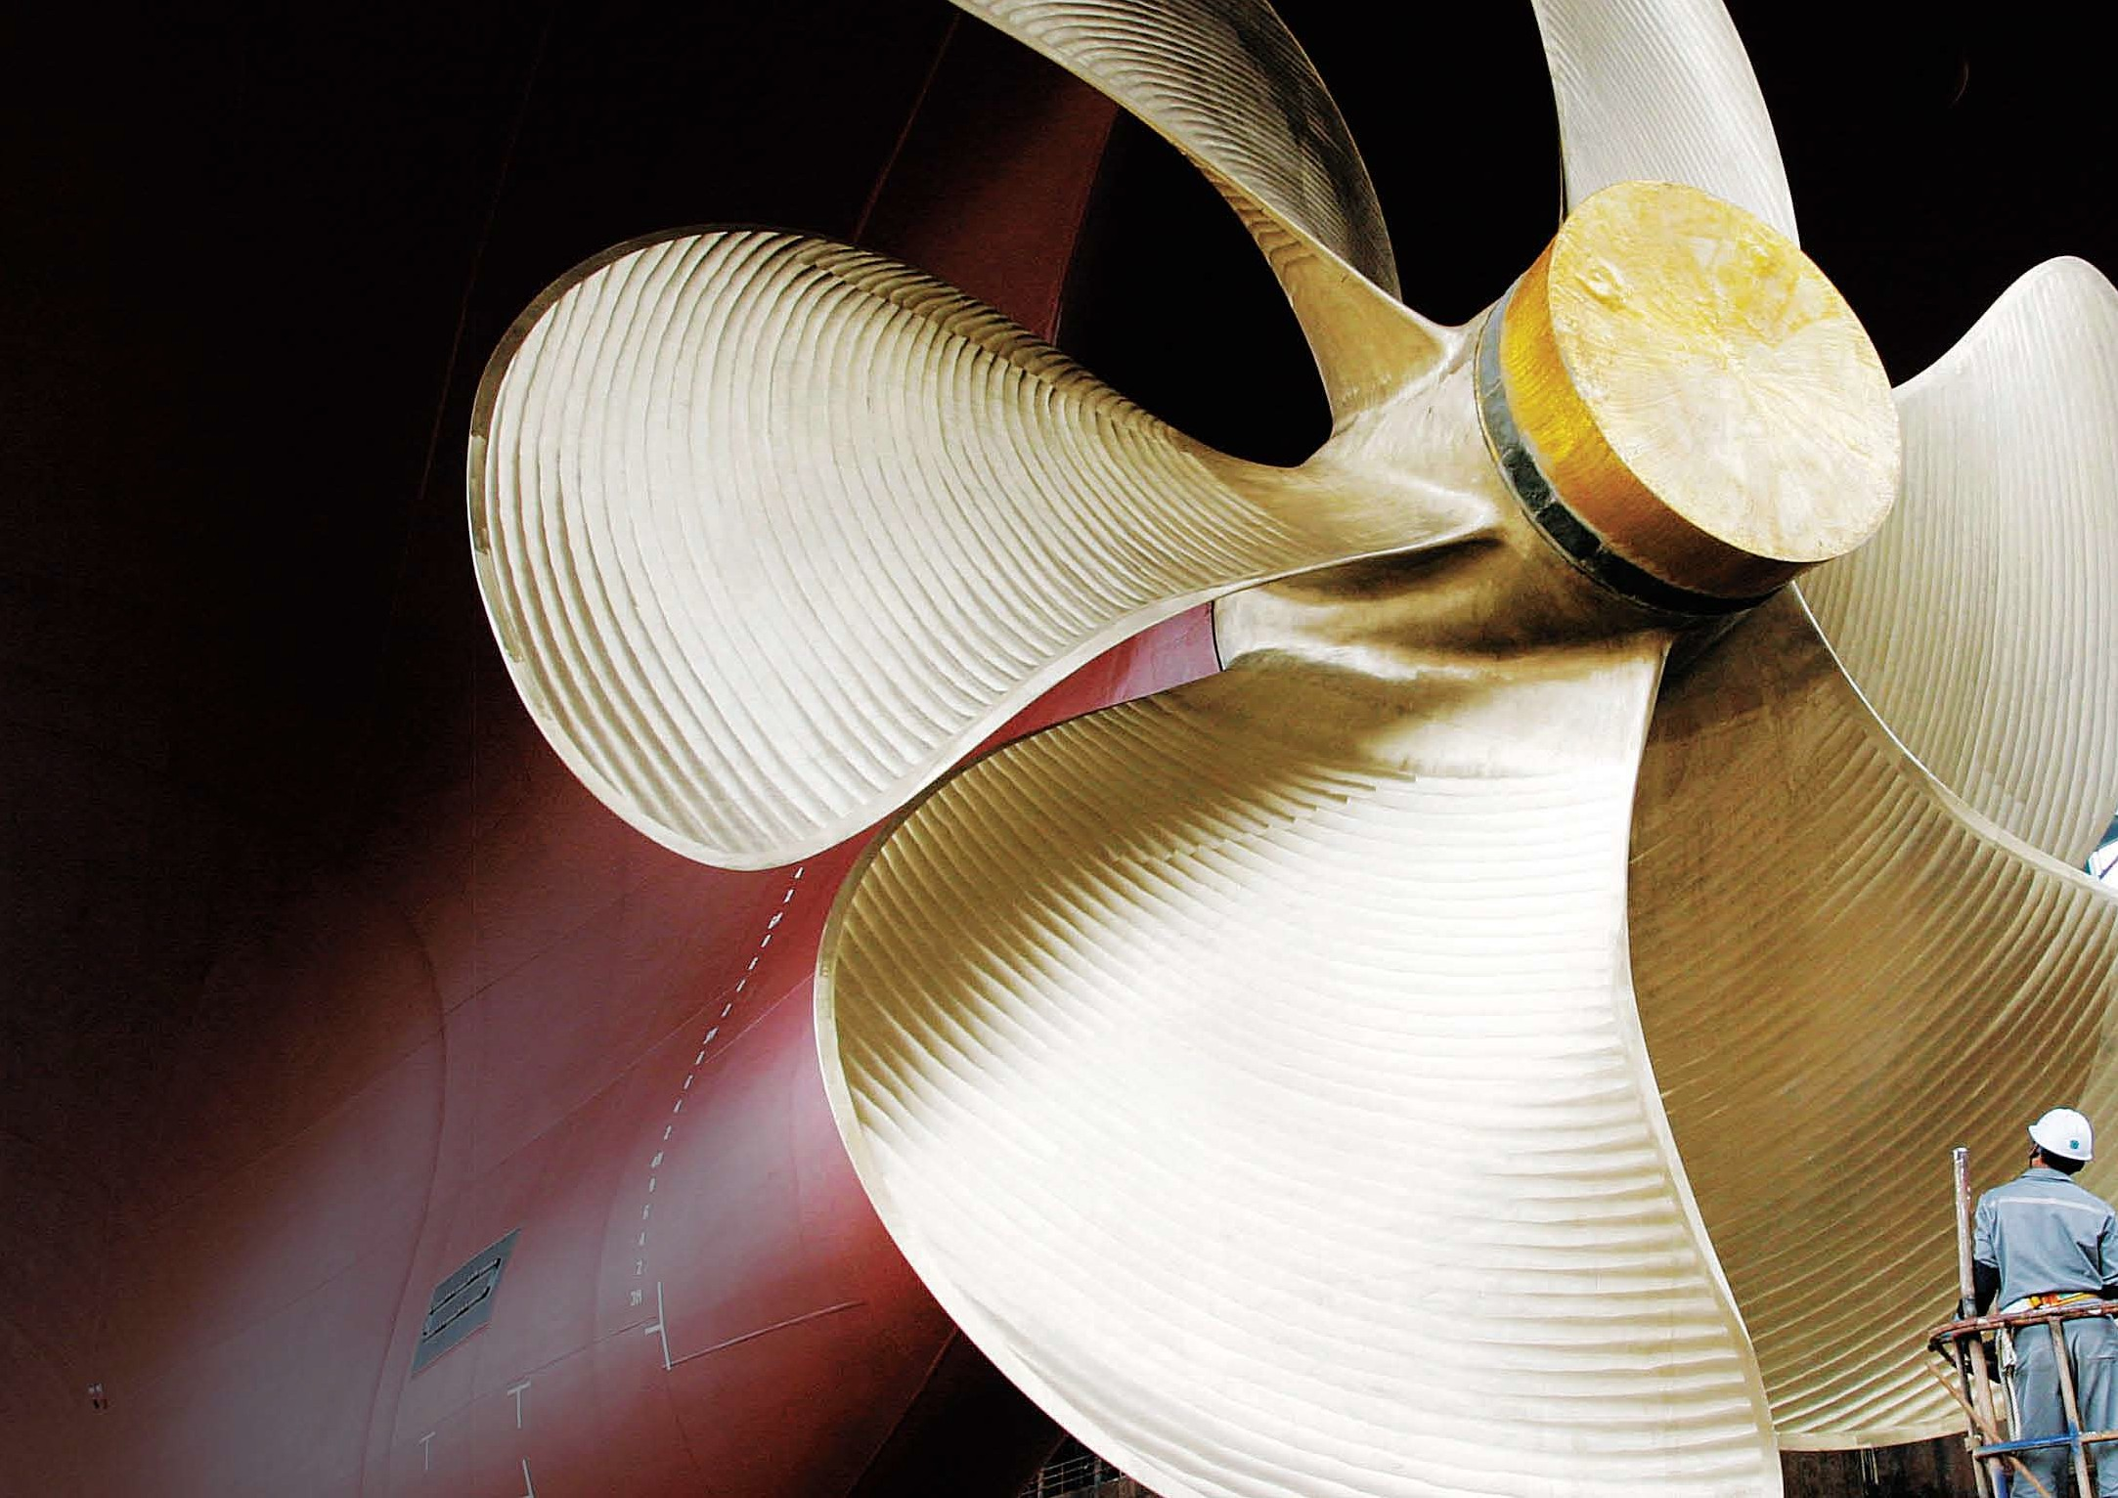

THE
GLOBALIZATION WITH GREEN TECHNOLOGY
Hyundai Heavy Industries (HHI) had its groundbreaking establishment in March 1972.
HHI’s main shipyard, located at Mipo Bay in Ulsan on the southeastern coast of Korea, spreads across 1,200 acres with its main production plants and all necessary auxiliary facilities covering over 800 acres. Since the successful delivery of its first two 260,000 DWT supertankers in 1974,
HHI has built and delivered almost every kind of ship to customers all over the world.

Backed by technology and experience acquired through streamlined modern facilities and highly skilled manpower in shipbuilding, HHI has diversified its business activities into other heavy industrial fields. On this vast compound, HHI operates various business lines: Shipbuilding, Offshore & Engineering, Industrial Plant & Engineering and Engine & Machinery.

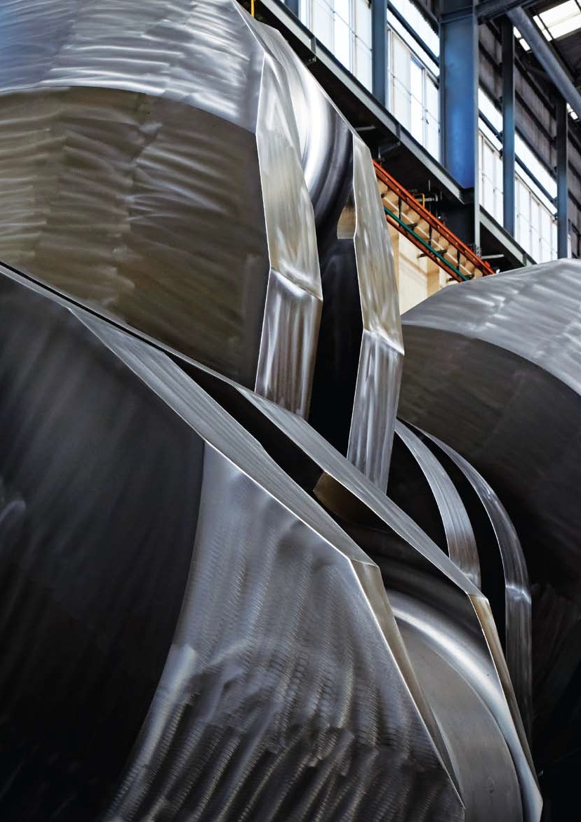
Contents
Introduction
- History
- HHI-EMD Zone
- HHI-EMD'S GROWTH
07 Business Areas

HHI-EMD PRODUCTS
Marine Engine
10 2-Stroke Engine
12 4-Stroke HiMSEN Engine
14 HiMSEN Propulsion System

Propeller & Shaft
18 Propeller & Shaft

Component
- Crankshaft
- Turbocharger

Marine Machinery
- Hi-Well Cargo Pumping System
24 Hi-GAS
26 Hi-ERS
28 Hi-ReGAS
30 NoNOx
32 HiBallast Ballast Water Treatment System
34 EcoBallast Ballast Water Treatment System
36 HiEMS
- HiCAS

Engine Power Plant
- Engine Power Plant
40 Packaged Power Station

HHI-EMD PRODUCTION CAPABILITIES
Production Facility
- Foundry Shop
- Machining Shop & Assembly-Test Shop

Research & Development
- Quality Management
- Research & Development

Customer Service
- Hyundai Global Service
- HiMSEN Global Academy
50
Global Network
51
Contact Us

Global Leader
05/52
HHI Engine & Machinery Division
MARINE ENGINE

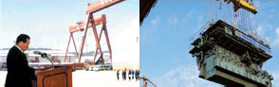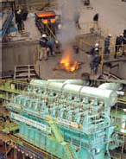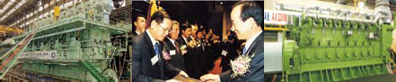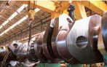History

1978 Completed the world’s largest marine engine plant in the Hyundai shipyard

1979 Produced the first marine engine (HYUNDAI- B&W 7L55GF)

1984 Produced the first crankshaft for the 2-stroke engine

1985 Produced the first marine propeller

1999 Completed world’s largest 200MW 2-stroke engine power plant in Chennai, India

2002 HiMSEN Engine was awarded as one of “Korea’s Top 10 Best New Technologies of 2000” Succeeded TAT of HiMSEN H25/33

2006 Developed Hyundai hydraulically driven cargo oil pumping system Succeeded TAT of HiMSEN H32/40

2007 Established “Wartsila Hyundai Engine” for DF50 engines for LNG carriers
Produced the world's most powerful 2-stroke diesel engine (Hyundai-Wartsila 14RT-flex96C, 108,920BHP)

2008 Developed high power HiMSEN Vee-Type (16H32/40V)
Launched Hyundai’s brand-new ballast water management system

2010 Achieved 2-stroke engine accumulated production with 100 million BHP Developed high output earth-friendly gas engine, H35G

2012 World’s first test run of LNG package solution for LNG-fueled ship Produced 1,000th packaged power station

2014 Developed the re-liquefaction system Hi-ERS

2015 Achieved 2-stroke engine production with an aggregate output of 150 million BHP

2016 Produced the 10,000th HiMSEN engine for the 14,400-TEU containership The confirmation test for NoNOx LP SCR with 2-stroke Engine

2017 Produced the 5000th marine propeller

06/52
Global Leader
MARINE ENGINE
HHI Engine & Machinery Division
Global Leader
07/52
HHI Engine & Machinery Division
MARINE ENGINE

HHI-EMD Zone
HHI-EMD’s Growth

MAIN OFFICE ZONE
- Main Building & Annex

ENGINE SHOP 1 ZONE
- Crankshaft Shop 1
- Machining Shop 1-1
- Machining Shop 1-2
- 4-Stroke Engine Ass’y & Test Shop 1
- 2-Stroke Engine Ass’y & Test Shop 2-1
- 2-Stroke Engine Ass’y & Test Shop 1-1
- 2-Stroke Engine Ass’y & Test Shop 1-2
- Propeller Shop 1
- Foundary Shop

ENGINE SHOP 2 ZONE
- 2-Stroke Engine Ass’y & Test Shop 2-2
- Machining Shop 2-1
- Machinery Ass'y Shop

ENGINE SHOP 3 ZONE
- Crankshaft Shop 2
- 4-Stroke Engine Ass’y & Test Shop 2
- 2-Stroke Engine Ass’y & Test Shop1-3

YARD 2 ZONE
- Machining Shop 1-3
HHI’s people are outstanding creators because:
•We have the passion to achieve the best
•We have innovative minds to change the world
•We endeavor to build trust based on honesty and integrity

As one of the leading engine builders in the world, HHI’s Engine
& Machinery Division (HHI-EMD) has enjoyed its reputation since its beginning in 1978. HHI-EMD has taken up 35% of the world's market share in engines for marine and stationary purposes. This shows that the superior quality of HYUNDAI engines is recognized by customers all over the world.

HHI-EMD has also developed its own engine brand HiMSEN, which is specially designed as part of the ongoing efforts to provide the most practical and highest quality engines to our customers.
Key advantages of the HiMSEN engine include reliability, durability, long service intervals, easy maintenance, cost efficiency in operation, and environmental friendliness. Based on its leading position in engine production, HHI-EMD has become the forerunner in the sector of engine power generation as well. A great number of its domestic and overseas engine power plants have given superb performance, contributing to the HYUNDAI’s high reputation.

The business activities of HHI-EMD have been further expanded into diverse fields of marine machinery such as marine pumps & turbines, ballast water treatment system and LNG gas solutions.

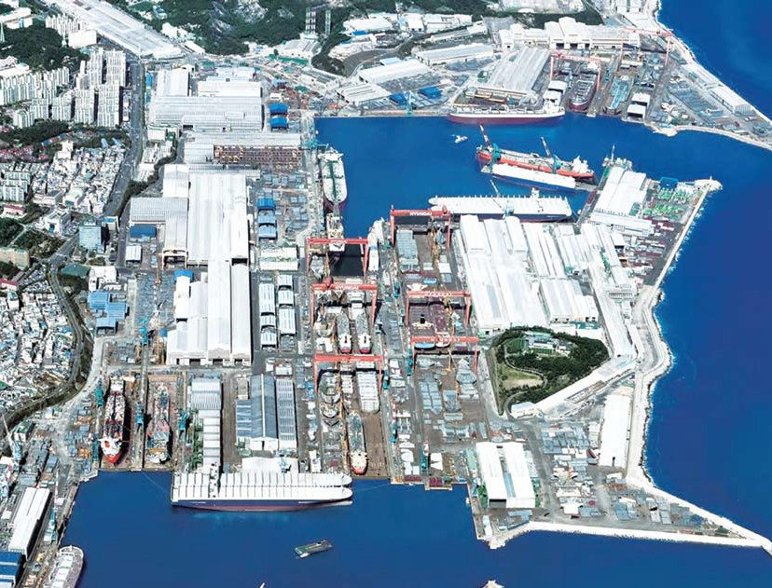HHI-EMD Business Areas
13
12
11
17
16
15
14
6
8
7
10
9
5
2
3
4
1

MARINE ENGINE & MARINE MACHINERY

2-Stroke / 4-Stroke Engines
•Diesel engines
•Gas engines
•Dual fuel (DF) engines
Engine Components
•Crankshaft, cylinder liner etc.
•Turbochargers
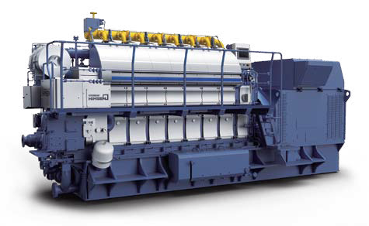Marine Eco Machinery
•Hi-Well cargo pumping systems
•Hi-GAS: Hyundai Integrated Gas Supply System
•Hi-ReGAS: Hyundai Integrated ReGASification System
•Hi-ERS: Hyundai Innovative Economical Re-liquefaction System

Propellers & shafts / Propulsion

Propellers & shafts
•Propellers, shafts, rudder stocks
Marine Propulsion
•HiMSEN Propulsion System

POWER PLANT

Stationary Engine Power Plants
•Heavy Fuel Oil (HFO
•Diesel Oil (DO)
•GAS
•Dual Fuel
Packaged Power Stations

Emergency diesel generator (EDG) for nuclear power plants
Barge-Mounted Engine Power Plants

HHI-EMD PRODUCTS

MARINE ENGINE PROPELLER & SHAFT
COMPONENT MARINE MACHINERY ENGINE POWER PLANT

10/52
Global Leader
MARINE ENGINE
HHI Engine & Machinery Division
Global Leader
11/52
HHI Engine & Machinery Division
MARINE ENGINE

2-Stroke Engine

HHI-EMD has supplied “One out of Three” of the world’s two-stroke engines for marine propulsion and power generation in pursuit of providing our valuable customers with high quality and economical solutions.
HHI-EMD's established reputation is supported by its superb performance in marine and stationary engines along with its state-of-the-art facilities such as foundry, machining, crankshaft, assembly and test shops.
Main Products •Hyundai-MAN Diesel & Turbo •Hyundai-WinGD •Engine Components

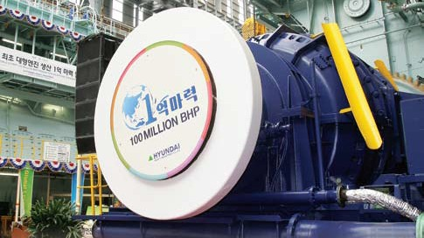
2

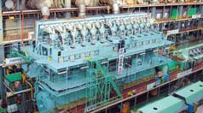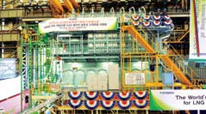
3 4
5 6

- 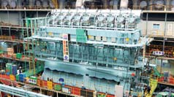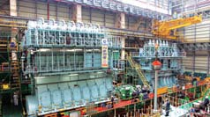2-stroke Engine Assembly & Test Shop
- HYUNDAI-WÄRTSILÄ 12RT- flex96C
- HYUNDAI-MAN B&W 8S70ME-GI
- HYUNDAI-WÄRTSILÄ-W9X82
- HYUNDAI-MAN B&W 7G80ME-C

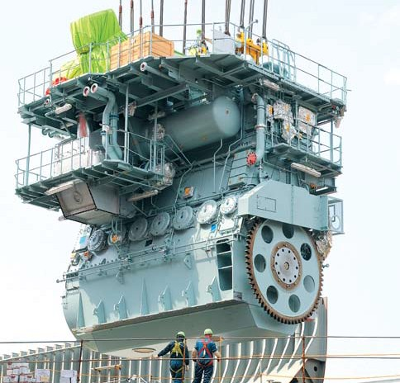Components •Bed plates
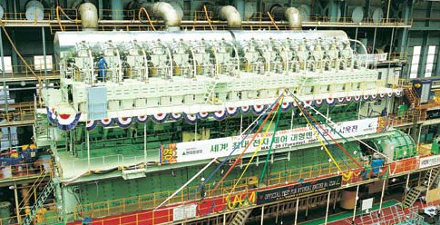•Cylinder heads
1
•Piston rods
•Frame boxes
•Cross head pins
•Connecting rods
•Cylinder liners
•Cylinder frames

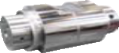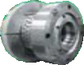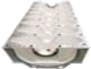

Frame Box Cross Head Pin Cylinder Head Bed Plate

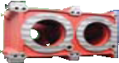

1. HYUNDAI-WÄRTSILÄ 14RT- flex96C

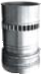Cylinder Frame Cylinder Liner Piston Rod Connecting Rod

12/52
Global Leader
MARINE ENGINE
HHI Engine & Machinery Division
Global Leader
13/52
HHI Engine & Machinery Division
MARINE ENGINE

4-Stroke HiMSEN Engine

HiMSEN engines are medium speed 4-stroke engines that HHI developed on its own after 10 years of R&D. and can be used for ship propulsion, power generation as well as at onshore plants. Since the first production of 4 units in 2001, HHI-EMD has delivered more than 10,000 units of this HiMSEN engines to 550 clients from 43 countries.
The HiMSEN engine features light-weight, high-output and high-efficient design and a wide range of lineup with models that can run on diesel and natural gas.
HiMSEN engine’s superior design has also been recognized in the market by winning design awards at the 2010 International Forum (iF) Design Award and Red Dot Design Award 2010 and the Federal Republic of Germany Design Award.
Rated Power for Marine GenSets

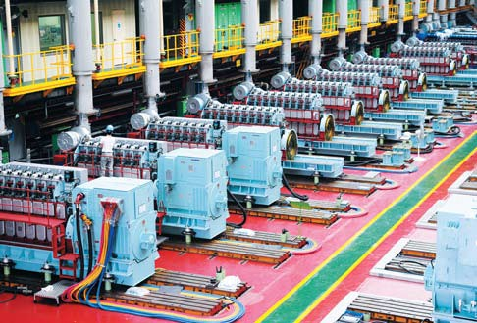 1

Engine(kW) Generator(kW)
H35DF
720/750
H35DFV 720/750
0 1000 2000 3000 4000 5000 6000 7000 8000 9000 10000
Model  H17/21V | rpm  1500/1800
H17/28 | 900/1000
H17/28E | 900/1000
H17/28U | 900/1000
H21/32 | 720/750
 | 900/1000
H21C | 900/1000
H25/33 | 720/750
 | 900/1000
H25/33V | 900/1000
H32/40 | 720/750
H32/40V | 720/750
H22CDF | 900/1000
H27DF | 720/750
 | 900/1000

Main Products •HiMSEN 4-stroke Diesel Engines
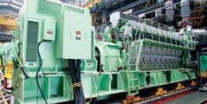•HiMSEN 4-stroke Gas Engines
2 3
4 5

- HiMSEN 4-stroke Dual Fuel Engines
- 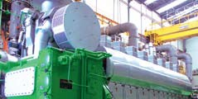Components
Components •Engine Blocks
•Cylinder Liners
•Connecting Rods

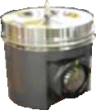

Piston
•Cylinder Head
•Pistons
•Piston Crowns
•Re-engine Services

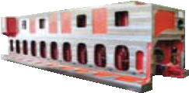

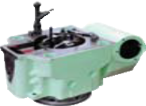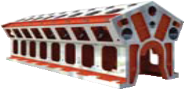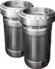Engine Blocks

- 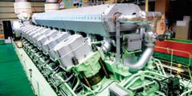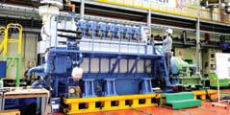HiMSEN Engine Assembly & Test Shop
- HiMSEN H35/40GV
- HiMSEN H35DF
- HiMSEN H46/60V
- HiMSEN H21C


Connecting Rod

Cylinder head Cylinder Liner

14/52
Global Leader
MARINE ENGINE
HHI Engine & Machinery Division
Global Leader
15/52
HHI Engine & Machinery Division
MARINE ENGINE

HiMSEN Propulsion System

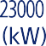HHI-EMD provides the HiMSEN Propulsion System with reliable, cost effective and environment-friendly solutions.

The optimized package includes:
•HiMSEN Diesel or Dual fuel engines
•C.P/F.P Propeller with shafting, Azimuth thruster
•Pitch and speed control
•Load control
•Reduction gear
•Shaft generator
•Auxiliary machinery

Performance Highlights
•Improved transient operation with pulse charging turbocharger
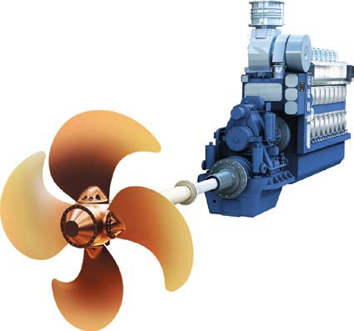•Invisible smoke
•Lower thermal load engine
•Low fuel consumption
•Low NOx emission

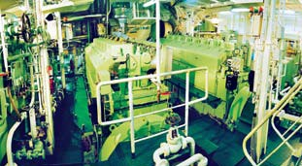Applications •Controllable pitch propulsion
•Fixed pitch propulsion
•Azimuth thruster propulsion
•Pump drive

Power Range

HiMSEN Dual-Fuel Engine
H22CDFP 1,100 - 1,980 kW

H27DFP 1,860 - 2,790 kW
H35DFP 3,000 - 4,500 kW
H35DFVP 6,000 - 10,000 kW

HiMSEN Diesel Engine
H17/21VP 1,920 - 3,200 kW
H21/32P 1,200 - 1,800 kW
H21CP 1,200 - 2,160 kW
H25/33P 1,740 - 2,610 kW
H32/40P 3,000 - 4,500 kW
H32/40VP 6,000 - 10,000 kW
H46/60P 7,500 - 11,250 kW
H46/60VP 14,400 - 22,500 kW

16/52
Global Leader
MARINE ENGINE
HHI Engine & Machinery Division
Global Leader
17/52
HHI Engine & Machinery Division
MARINE ENGINE

HiMSEN Propulsion System

HiMSEN Dual Fuel Engines for Propulsion
HiMSEN Diesel Engines for Propulsion

Model |  |  | H22CDFP H27DFP H35DFP H35DFVP
Bore |  | mm | 220 | 270 | 350 | 350
Stroke |  | mm | 330 | 330 | 400 | 400
Speed |  | r/min. | 1,000 | 1,000 | 750 | 750
Cylinder output |  | kW/ cyl. | 220 | 310 | 500 | 500
Rated output #) |  | cyl. 5  6  7  8  9  12  14  16  18  20 | kW
 |  |  | 1,100  1,320  1,540  1,760  1,980 | 1,860  2,170  2,480  2,790 | 3,000  3,500  4,000  4,500 | 6,000  7,000  8,000  9,000  10,000
SFOC *)  on Diesel mode | at 100% MCR | g/kWh | 192.0 | 186.0 | 185.0 | 185.0
 | at 85% MCR |  | 196.0 | 185.0 | 184.0 | 184.0
Heat rate *) on Gas mode | at 100% MCR | kJ/ kWh | 8,079 | 7,728 | 7,270 | 7,270

Model |  |  | H21/32P | H21CP H25/33P H32/40P H46/60P H17/21VP H32/40VP H46/60VP
Bore |  | mm | 210 | 210 | 250 | 320 | 460 | 170 | 320 | 460
Stroke |  | mm | 320 | 330 | 330 | 400 | 600 | 210 | 400 | 600
Speed |  | r/min. | 900 | 900 | 900 | 750 | 600 | 1,800 | 750 | 600
Cylinder output |  | kW/ cyl. | 200 | 240 | 290 | 500 | 1,250 | 160 | 500 | 1,250
Rated |  | cyl. | kW
 |  | 5 | 1,200 | 1,200 | 1,740/  1,800 | 3,000 | 7,500 | 1,920 | 6,000 | 15,000
 |  | 6 |  | 1,440
 |  | 7 | 1,400 | 1,680 | 2,030 | 3,500 | 8,750
 |  | 8 | 1,600 | 1,920 | 2,320 | 4,000 | 10,000
 |  | 9 | 1,800 | 2,160 | 2,610 | 4,500 | 11,250
output #) |  | 10
 |  | 12
 |  | 14 |  |  |  |  |  |  | 7,000
 |  | 16 |  |  |  |  |  | 2,560 | 8,000 | 20,000
 |  | 18 |  |  |  |  |  | 2,880 | 9,000 | 22,500
 |  | 20 |  |  |  |  |  | 3,200 | 10,000
SFOC *)  on | at | g/kWh | 183.0 | 183.0 | 181.0 | 184.0 | 177.0 | 199.0 | 186.0 | 177.0
 | 100% MCR
Diesel | at 85% MCR |  | 183.0 | 179.0 | 181.0 | 181.0 | 174.0 | 196.0 | 181.0 | 174.0
mode

*) Note
  - Reference condition based on ISO 3046/1
  - Fuel oil based on LCV (Lower Calorific Value) 42,700kJ/kg
  - Gas operation: Including pilot fuel oil and fuel gas based on LHV (Lower Heating Value) 35MJ/Nm3, MN80
  - Tolerance +5% and without engine driven pumps
  - NOx Emission limitation: IMO Tier II on Diesel mode, IMO Tier III on Gas mode
#) Based on the CPP Constant speed operation (For FPP : Please contact HHI EMD)

*) Note
- Reference condition based on ISO 3046/1
- Fuel oil based on LCV (Lower Calorific Value) 42,700kJ/kg
- Tolerance +5% and without engine driven pumps
- NOx Emission limitation: IMO Tier II
- H17/21VP Model: Only applicable on MGO operation
#) Based on the CPP Constant speed operation (For FPP : Please contact HHI EMD)

18/52
Global Leader
PROPELLER & SHAFT
HHI Engine & Machinery Division
Global Leader
19/52
HHI Engine & Machinery Division
PROPELLER & SHAFT

Propeller
& Shaft
HHI-EMD produces a wide variety of marine propellers with a diameter up to 11 meters and a maximum unit weight of 114 tons. The main materials are manganese bronze and nickel-aluminum bronze.
HHI-EMD employs a comprehensively computerized design, manufacturing and inspection system for these products.

Propeller Shop •Maximum: 114 tons in Weight, 11 m in Diameter
•Minimum: 10 tons in Weight, 3 m in Diameter

Shaft & Rudder Stock
Products
•Propeller shaft •Intermediate shaft
•Straight type rudderstock

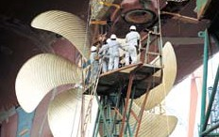

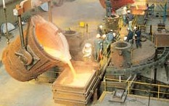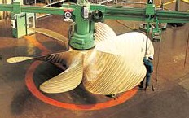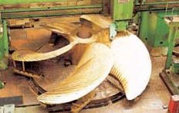1. World’s Largest Propeller Weight 110.2 tons Diameter 10.4 m
Blade 5
Shiptype 18,800 TEU Container- ship
•Machining Equipment: NC Blade Milling M/C x 3 sets
•Boss Boring M/C x 3 sets
•Riser Cutting M/C x 2 sets
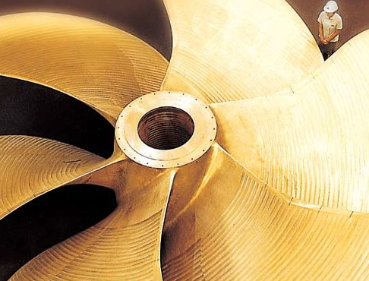•Horizontal Balancing M/C x 2 sets
1
Max. Production •150 tons in Weight
•2,200 mm in Diameter
•18,000 mm in Length

Min. Production •300 mm in Diameter
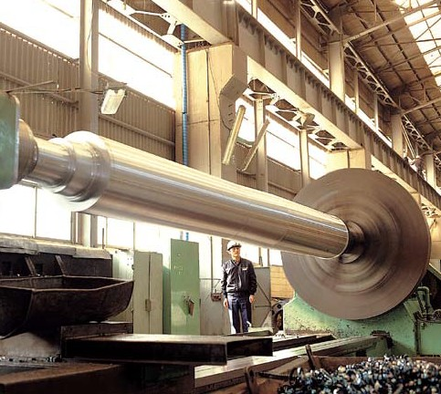•2,000 mm in Length

20/52
Global Leader
COMPONENT
HHI Engine & Machinery Division
Global Leader
21/52
HHI Engine & Machinery Division
COMPONENT

Crankshaft

HHI-EMD produces semi-built-up and mono-block crankshafts, using the most up-to-date CNC and NC heavy-duty crankshaft and crank-throw lathes.
Main Products •2-stroke engine crankshaft
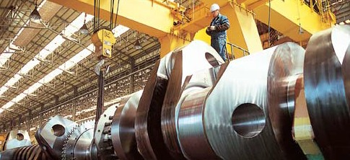•4-stroke engine crankshaft
1
Turbocharger

Based on its wealth of experience and technology in manufacturing engines and precision machinery, HHI-EMD produces exhaust gas turbochargers under a technical tie-up with ABB Turbo Systems and Mitsubishi Heavy Industries (MHI).

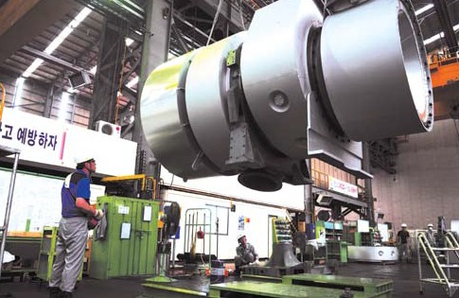

Main Products 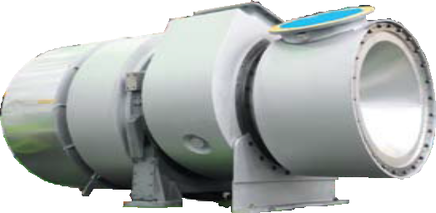

ABB TPL & A Type: A165 / A265 / A270 / A175 / A275 / A180 / A280 / A185 / A285 / A190

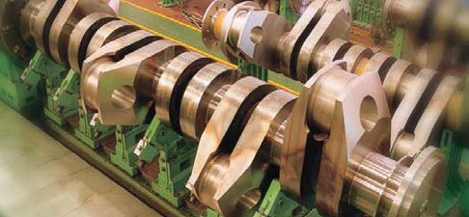
2
- 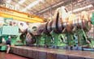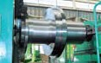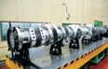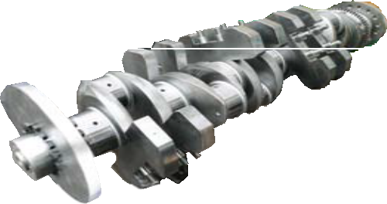2-stroke Engine Crankshaft Assembly
- 4-stroke Engine Crankshaft

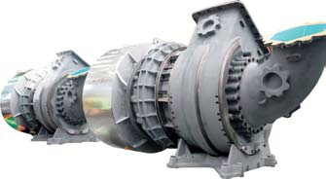MHI’s MET Type: MET66MB / MET71MB / MET83MB / MET90MB

22/52
Global Leader
MARINE MACHINERY
HHI Engine & Machinery Division
Global Leader
23/52
HHI Engine & Machinery Division
MARINE MACHINERY

Hi-Well Cargo Pumping System
How It Works

TM
Hi-Well Cargo Pumping System is based upon hydraulically driven submerged cargo pumps for
chemical and product carriers, crude carriers, FPSO units and others.
The system is designed for efficient cargo handling, stripping and tank cleaning. Hi-Well is designed, manufactured and factory-tested by computer-aided technology and the most qualified expert engineers.

Components
Major
•Hi-Well cargo pump
•Hydraulic power package
•Control system
•Ballast pump
•Portable pump with winch
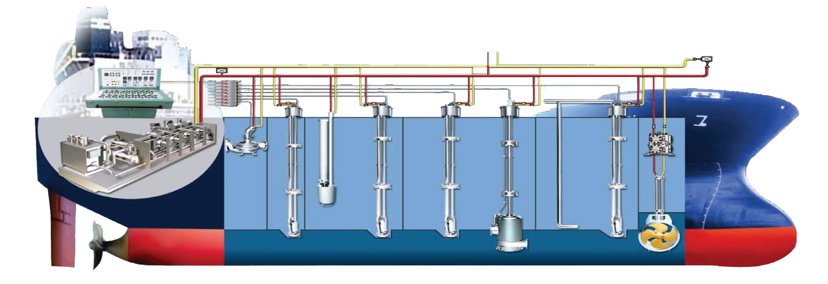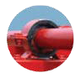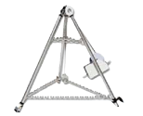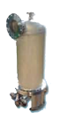•Tank cleaning pump
•Hydraulic oil transfer pump
Optional
•Diffuser
•Side thruster & Control block
•Cargo heater

Discharging Stripping Purging and Seal-leakage
Check

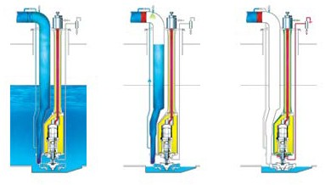OTHER CONSUMER
Hydr. Oil Press Line Hydr. Oil Line

Pilot Line

24/52
Global Leader
MARINE MACHINERY
HHI Engine & Machinery Division
Global Leader
25/52
HHI Engine & Machinery Division
MARINE MACHINERY

Hi-GAS Hyundai integrated Gas Supply System
Applications
HHI-EMD is lined up with the complete range of LNG packaged solutions for LNG carriers and LNG- fueled ships.

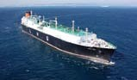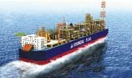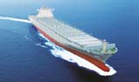TM
Packaged Solution: LNG Fuel Gas Supply System
As the LNG market is steadily developing due to the environmental and economic benefits, the demand for LNG carriers and LNG-fueled ships is increasing. As high-efficient dual-fuel engines become a preferred prime mover choice for the engine market, HHI-EMD is readily lined up with both ME-GI engines and 4-stroke dual-fuel HiMSEN engines.
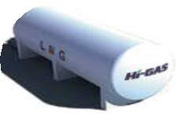Hi-GAS is a remarkable design of LNG fuel gas supply system for dual-fuel engines based on high- and low- pressure supply. Hi-GAS can effectively supply high-pressure compressed natural gas (CNG) to ME-GI engines while supplying low-pressure CNG to 4-stroke DF GenSets, which operate with two fuel supply systems.

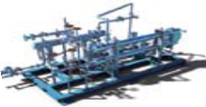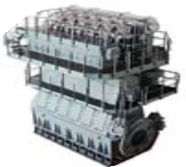

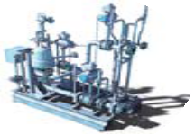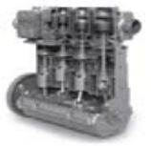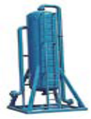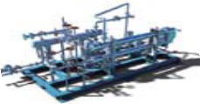Forcing Vaporizer & Heating System
Booster Pump (LP)
Forcing Vaporizer & Heating System
▲
▲
  - DF Engine

*BOG Handling & Treatment System
▲
▲
▲
▲
▲
▲
▲
▲
▲
▲
▲
▲
▲
▲
▲
▲
▲
▲
▲
▲

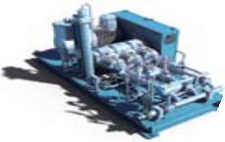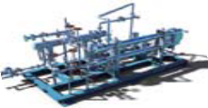HP Pump (HP)

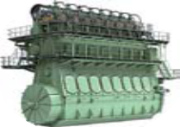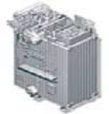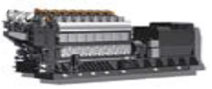Vaporizer & Heating System

HiMSEN DF
Engine

DF Boiler
[ Remark ]
    - BOG Handling & Treatment Systems are necessary for the Type B tank.
    - X-DF and HiMSEN engine are required to handle the methane number.

ME-GI Engine

26/52
Global Leader
MARINE MACHINERY
HHI Engine & Machinery Division
Global Leader
27/52
HHI Engine & Machinery Division
MARINE MACHINERY

Hi-ERS Hyundai Innovative Economical Re-liquefaction System

HHI-EMD has developed Hi-ERS, Hyundai Innovative Economical Re-liquefaction System that can partially liquefy the boil-off gas (BOG) of LNG carriers by combining the high-pressure compressor for ME-GI engines.
Hi-ERS features simple configuration, robust operation, reliable components and high safety system satisfying the requirements of customers.
To achieve energy saving through recovering cold energy from the system, the highly efficient and compact plate type BOG heat exchanger is installed between the LNG cargo tank and the suction of high-pressure compressor. The BOG heat exchanger is intended to cool down compressed BOG by cold heat from BOG which has temperature approximately between -120℃ and -90℃ and flash gas from LNG separator to improve the system efficiency of Hi-ERS.
The Joule-Thomson valve expands the compressed BOG in its cold state to a targeted low pressure and simultaneously lowers it to the condensing temperature of BOG.
By using Hi-ERS, simple and economical re-liquefaction of BOG can be achieved.

How It Works
The LNG carrier’s cargo tanks are insulated for a slightly sub-cooled condition.
LNG cargo handling system controls the BOG to prevent overpressure of the LNG cargo tank during transportation by removing or extracting BOG.
The High Pressure Compressor (HPC) primarily controls the cargo tank pressure and compresses the BOG with five-stage compressors to supply fuel gas to ME-GI engines for the propulsion.
In case the cargo tank pressure is over the pressure set-point, Hi-ERS will start to work.

•Higher BOG Flow Rate Than Gas Demand
- Excessive BOG is sent to Hi-ERS through Joule-Thomson Valve and partially condensed.
- Excessive BOG beyond ERS’s capacity is compressed and sent to GCU, DF generator or boiler, etc.

•Lower BOG Flow Rate Lower Than Gas Demand
- LNG fuel gas supply stems operates to control required gas pressure and amount.

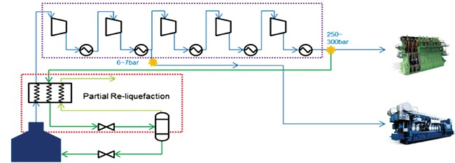High Pressure Compressor
250-
3000bar
6-7bar

Partial Re-liquefaction
LNG Cargo Tank

1

- 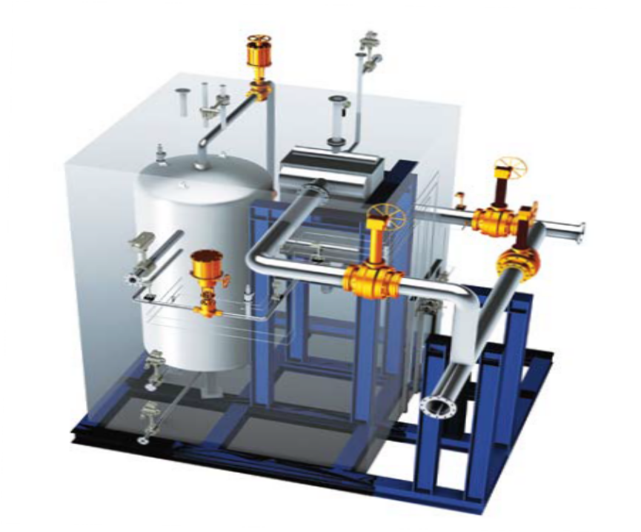Hi-ERS basically consists of BOG heat exchanger, Joule-Thomson valve, and LNG separator.

Main Equipment

- 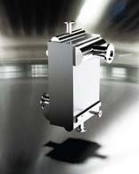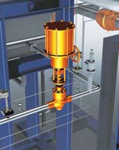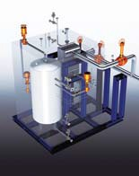BOG Heat Exchanger
2 3 4
- Joule-Thomson Valve (J-T valve)
- LNG Separator

28/52
Global Leader
MARINE MACHINERY
HHI Engine & Machinery Division
Global Leader
29/52
HHI Engine & Machinery Division
MARINE MACHINERY

Hi-ReGAS Hyundai Integrated Regasification System
Suction Drum with BOG Recondenser
The suction drum functions as a buffer tank for booster pumps. The internal packing material of the suction also provides BOG recondensing function by enhancing the contact surfaced between the compressed BOG and the subcooled LNG into the suction drum.

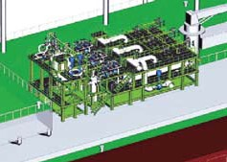HHI-EMD’s Hi-ReGAS, Hyundai Integrated Regasification System is engineered to vaporize LNG and offload LNG onto onshore pipelines. Hi-ReGAS provides two types of LNG heating methods: seawater direct heating type and seawater/glycol-water indirect heating type.
The seawater direct heating type gives attractive benefits:
low fuel consumption, low space occupation, easy operation and quick startup and shutdown.
The seawater/glycol-water indirect heating type has other advantages: lower corrosion risk and freezing risk. Hi-ReGAS provides notable features (optimized seawater pipeline routing and space utilization) through the optimal integrated configuration of both regasification module and hull sides.
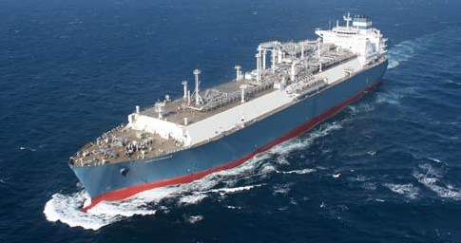Hi-ReGAS is mainly composed of LNG suction drums, booster pumps and vaporizers. The pump and vaporizer can be packaged in a modular way for each train.

LNG Booster Pump

LNG Vaporizer

NG Heater
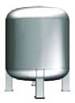(only for in-direct type)

  - 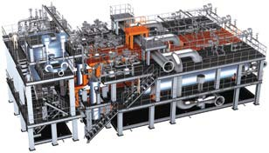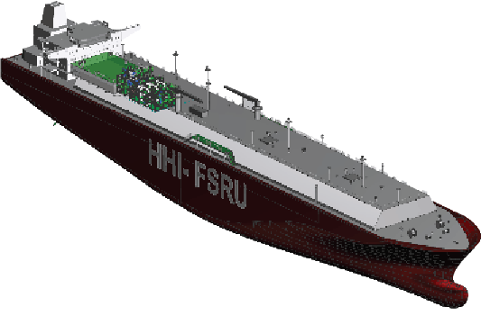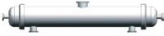CSuction Drum with BOG Recondenser
Suction Drum
LNG Booster pump
LNG Vaporizer (Shell & Tube type)
  - LNG Booster Pump
  - LNG Vaporizer

Each train has an LNG booster pump with the rated capacity of 125 mmscfd at 100 bar head. The pumps are assorted into multistage, vertical, submerged, and pot-mounted types.

LNG vaporizers are installed at each train to vaporize the LNG. In the process, the shell- and tube-type heat exchanger heats LNG with sea water in case of seawater direct heating type. In the case of the seawater/glycol-water indirect heating type, LNG vaporizers utilize glycol-water as a heating medium circulating in the closed loop.

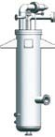NG heaters (printed circuit heat exchanger type, PHCE) are installed at the downstream of LNG vaporizers to increase NG temperature for the requirement of end user. The application of these heat exchangers can minimize the size and weight of the regasification trains.
1 2
3

30/52
Global Leader
MARINE MACHINERY
HHI Engine & Machinery Division
Global Leader
31/52
HHI Engine & Machinery Division
MARINE MACHINERY

NoNOx Hyundai SCR
TM

(Selective Catalyst Reduction)

System
HP SCR for 2-stroke engine



Certification of NoNOx SCR System

NoNOxTM is a brand name of the Hyundai SCR (selective catalyst reduction) System that can reduce NOx up to 95% and meet IMO Tier lll regulation.
•Most reliable design for marine application
•Best adoptability for onboard installation
•Most convenient for verification and operation

SCR system and relevant certification procedure for marine application is defined by IMO.
According to resolution MEPC.198(62), SCR system is considered as an engine component. Therefore, instead of separate certification of SCR system, IMO NOx verification in combination with engine is required according to Scheme A and Scheme B.

Control Unit

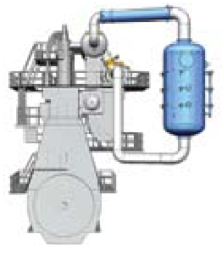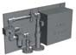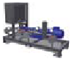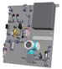 Mixing Unit Urea Dosing Unit

Venting & Sealing Unit
SCR Chamber
intergrated soot blowing unit and standby heat unit

Compressed Air

Urea Solution

NoNOx SCR system can be verified and receive IMO NOx Tier III certification at HHI-EMD test-bed
according to Scheme A.
Technical fi(lTeieisrsIIuI)e
Control Unit

Scheme
NOx mea(TsiuerreImII)ent
A

Scheme
NOx mea(TsiuerreImI) ent

B

SCR
scale test
Technical f(iTleieirsIsIu&e expected Tier III)

Onboard verification

Resolution MEPC.198(62)

EIAPP
ce(TrtieifricIIaI)te

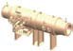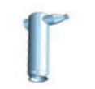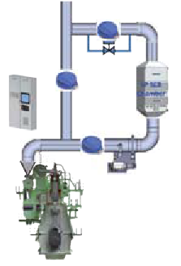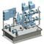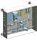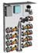LP SCR for 2-stroke engine
SCR Chamber
interagted soot blowing unit
Soot Blowing Unit
Control Unit
AIG & Mixing Unit
Urea Dosing Unit
Burner
UDC
(Urea Decomposition Chamber)
Urea Solution

Urea Supply Unit
Compressed Air

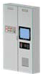Main Components LP SCR for 4-stroke engine

NoNOx Mini-SCR

NoNOx Mini-SCR technology can offer more compact size and lower cost compared to the original SCR. The Mini-SCR is designed considering essential minimized engine load called 2nd-MCR only for Tier III mode because the engine generally would not run at high load in ECA(Emission Control Area). The engine load will be limited according to operating mode (Tier II or Tier III). Size of the Mini-SCR can decrease approx. 70~85% of original one, hence CAPEX and OPEX can be reduced.

Urea Supply Unit

Urea Solution
Tier II (MCR)

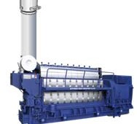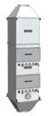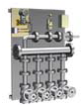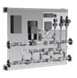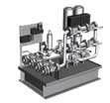Tier III (2nd-MCR)
SCR Chamber
Control Unit
Soot Blowing Unit
Mixing Unit
Compressed Air
Urea Dosing Unit

25%

25%

50%

75%

50%

100%

75%

ECA Only Operation with Mini-SCR

100% SMCR

32/52
Global Leader
MARINE MACHINERY
HHI Engine & Machinery Division
Global Leader
33/52
HHI Engine & Machinery Division
MARINE MACHINERY

HiBallast Ballast Water Treatment System
Key Features & Benefits
Easy Installation •No changes to the existing ship design
•Space-saving installation with modular design, suitable for retrofit

HiBallast is a disinfection system by electrolysis of seawater with the following characteristics:

•Components: Filter, Electrolysis Unit, Neutralization Unit, TRO Sensing Unit
•Required Sea Water Capacity for Electrolysis: only 1% of total ballast capacity
•Disinfectants: Sodium hypochlorite
•Neutralizing Agent: Sodium thiosulfate
•Safety First: No harm to human & vessel, No danger by H2 gas separation, no risk of damage to ballast tank coating
Automatic Operation

Economic Operating Cost

Convenient maintenance and A/S
•Feedback control of each unit with human-machine interface
•Both automatic and manual operation
•Automatic treatment rated capacity (TRC) control

•Low fuel cost because of lower power consumption
•Longer lifetime of electrodes

•Modular type system
•Easy replacement for engineer/ship staff
•Global support and worldwide A/S network

How it Works
Main application •Any vessel types including oil tankers, containerships and gas carriers
•Ballast water capacity: 75 to 10,000 m3/hr


FIELD
ENGINE ROOM OR OTHER PLACE
SKID
ENGINE ROOM OR OTHER PLACE

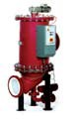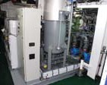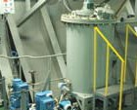Control System Configuration
Electrolysis Unit
Produce disinfectant to kill virus, pathogenic bacteria and other organisms smaller than 50µm.
Filter
Remove particles or organisms larger than 50µm.
Neutralization Unit
Neutralize the solution of sodium thiosulfate in de-ballasting and convert any residual oxidants into stable form such as chloride and bromide.
Ballasting Operation
ELECTROLYSIS UNIT
FILTER
Ballast Pump
BALLAST TANK
De-Ballasting Operation

Overboard
NEUTRALIZATION UNIT
CCR

CENTRAL CONTROL ROOM

Rectifier

Electrolyzer
Intergrated Automation System or Console
Operator Station
Data Network
Alarm Logger
ELECTRIC POWER
System Control Cabinet
Disinfectant
Injection Pump
Blower
INSTRUMENT AIR
Valves
Instruments
FEED Pump
N.A. Injection
Pump

34/52
Global Leader
MARINE MACHINERY
HHI Engine & Machinery Division
Global Leader
35/52
HHI Engine & Machinery Division
MARINE MACHINERY

EcoBallast Ballast Water Treatment System

EcoBallast is an ultra-violet disinfection system with the following characteristics:
•Components: Filter, UV Reactor, CIP (Cleaning In Place) Unit
•Disinfectants: UV-C light
•Environment-friendly disinfection process
•Safety First: Not harmful to human and vessel
Main Features

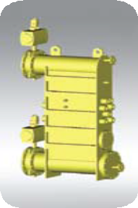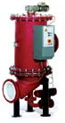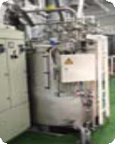How it Works

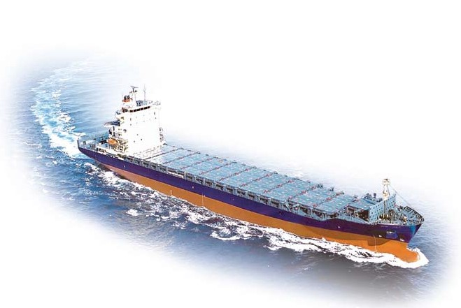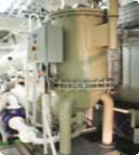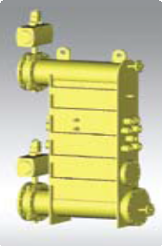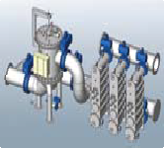CLEANING UNIT
Filter
- High performance
- Small footprint
- Full automation
- Easy maintenance
- Low maintenance cost
UV Reactor
- Highly efficient
- Unique and robust design
- Automatic TRC (treatment rated capacity) control
Electronic Ballast Device
- High reliability and efficiency
- Longer lifetime
Chemical Free
- Does not use or produce any chemical
- Prevent risks to the ship, its ballast tank coating, the crew and the marine environment

Ballast Pump Discahrge
FILTER UV REACTOR

Ballast Tank or Overboard

Filter
Remove particles or organisms larger than 50µm.

UV Reactor

ENGINE ROOM
FIELD

ENGINE ROOM OR OTHER PLACE
Disinfect virus, pathogenic bacteria and other organisms smaller than 50µm.

The ballast water is treated during ballasting and once again during de-ballasting

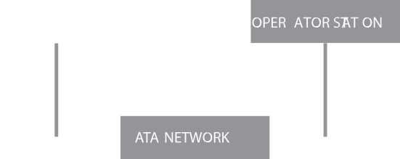Control System Configuration
Intergrated Automation System or Console
Ballast Cabinet
Operator Station
Alarm Logger
Data Network
Control Cabinet / Control Panel
ELECTRIC POWER

CONTROL POWER
UV Reactor
Filter
Valves
Instruments
CCR

CENTRAL CONTROL ROOM

36/52
Global Leader
MARINE MACHINERY
HHI Engine & Machinery Division
Global Leader
37/52
HHI Engine & Machinery Division
MARINE MACHINERY

HiEMS Hyundai Intelligent Engine Monitoring System HiCAS Hyundai Intelligent Combustion Analysis System

How It Works
HiEMS, HiMSEN Engine Monitoring System offers a real-time engine status and transfers alarm and fault messages to remote offices and staff when detecting the abnormalities.
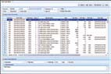HiEMS provides troubleshooting clues to marine engineers in detail, while onshore service engineers receive operational data for failure analysis.
Hi-CAS is an on-line engine indicating system to acquire and process in-cylinder pressure data referenced to crank angle. Once data is loaded into the analysis software, engine’s thermodynamic cycle is analyzed on the cycle-to-cycle and cylinder-to-cylinder basis.
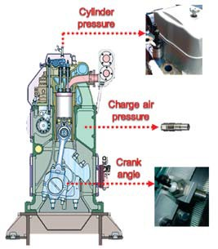To achieve optimum thermodynamic and mechanical engine behavior during entire life cycle, HiMSEN engines give two kinds of on-line monitoring applications. This diagnostic package helps detect engine abnormalities more quickly and save maintenance cost.
Cylinder Pressure
Charge Air Pressure
Crank Angle

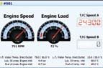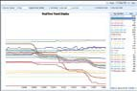Engine Status Monitoring
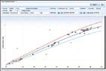Display main TAG of all engines and detail monitoring of specific engine.

Performance Curve based Analysis
Display performance status in comparison to the result of ‘official shoptest’ considering engine load.
Trend Analysis
Real-time/History View engine operation over time and detect the abnormalities early.

Deviation based Analysis
Display deviation from the aver- age of cylinders, turbochargers.
Alarm/Fault Management
Managing the log data deviated from the criteria of the alarm/ fault configured initially and spreading to onboard and onshore office.

Key Features & Benefits

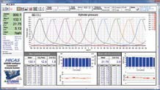

•In-cylinder peak pressure & IMEP monitoring
•Cycle-to-cycle variation
•Cylinder-to-cylinder distribution
•Fault diagnosis of cyclic moving parts

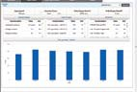

Key Features & Benefits
Remote Monitoring
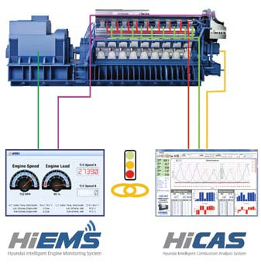Display overall status of engine and alarm/fault event from the vessel. Provide the report that contains engine performance data.
Crank shaft movement
Fuel.press.[opt] Cyl.press.
Eng.status
Gen.status

•Real-time engine status monitoring and analysis reporting
•Signal data spreading of alarm/fault by e-mail.
•Data transfer of engine operation and performance analysis
•Self-diagnosis by ‘interactive failure cause analysis program’
•Easy engine status monitoring, performance measuring and reporting
•Service of variable information to be checked by additional process during specific period
•Prompt check detects and engine status information in remote sites
•Service of specific technical assistant from special engineers

38/52
Global Leader
ENGINE POWER PLANT
HHI Engine & Machinery Division
Global Leader
39/52
HHI Engine & Machinery Division
ENGINE POWER PLANT

Engine Power Plant
Prime Mover:
HHI-EMD provides a range of services for establishing an engine power plant:

Prime Mover:
2-Stroke Engine

Since the first completion of 20MW-diesel power plant in Jeju, South Korea, HHI-EMD has expanded its presence as an EPC contractor into the global power industry and completed quality diesel power plants around the world.
HHI-EMD successfully completed a 60MW diesel power plant in Israel, a 50MW and a 36MW diesel power plant in Malaysia, a 200MW diesel power plant in India (the largest diesel power plant in the world using a diesel engine as its prime mover), two 30MW diesel power plants in Mauritius, and a 42MW diesel power plant in Mexico.

4-Stroke Engine
•Feasibility study
•Financial resource assistance
•Operation and maintenance
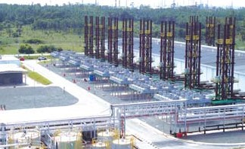•Training
•Rehabilitation
•Tool and spare parts supply
•Local presence of expert personnel

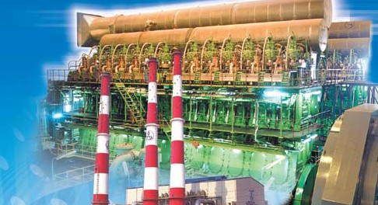

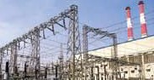GMR Vasavi 200MW Diesel Power Plant, India(HYUNDAI-MAN B&W 12K90MC-S x 4)

Range of 2-Stroke Stationary Engine

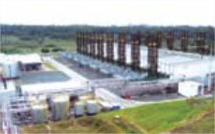

Range of 4-Stroke Stationary Engine
Engine  Model Type |  | Power Range
HiMSEN | H21/32 | 1,200 - 1,800 kW
 | H21C | 1,200 - 2,160 kW
 | H25/33 | 1,740 - 2,700 kW
 | H25/33V | 3,840 - 6,400 kW
 | H32/40 | 2,850 - 4,275 kW
 | H32/40V | 5,700 - 9,500 kW
 | H35/40G | 2,880 - 4,320 kW
 | H35/40GV | 5,760 - 9,600 kW
 | H27DF | 1,710 - 2,790 kW
 | H35DF | 2,880 - 4,320 kW
 | H35DFV | 5,760 - 9,600 kW
 | H46/60V | 14,400 - 22,500 kW

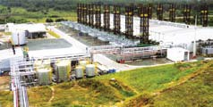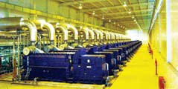
Diesel Engine  Model Type |  | No. of Cylinders | Speed(rpm)  50Hz 60Hz |  | Output(kW)/Cylinder  50Hz 60Hz
HYUNDAI- | K98MC-S | 9 -14 | 103.4 | 102.9 | 5,680 | 5,650
 | K90MC-S | 7-12 | 107.1 | 109.1 | 4,290 | 4,260
 | K80MC-S | 7-12 | 107.1 | 109.1 | 3,390 | 3,360
 | K60MC-S | 7-14 | 150 | 150 | 1,980 | 1,980
MAN B&W | K50MC-S | 7-14 | 176.5 | 180 | 1,420 | 1,450
 | L42MC-S | 7-12 | 187.5 | 189.5 | 1,060 | 1,070
 | L35MC-S | 7-12 | 214.3 | 211.8 | 645 | 640

3 3
4 4

1
2

- 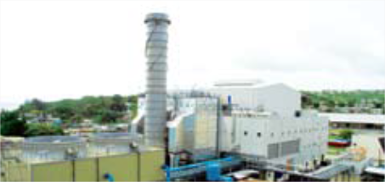Fort George 60MW Diesel Power Plant, Mauritius (HYUNDAI-MAN B&W 9K80MC-S x 2)
- 60MW BLPC Diesel Power Plant, Barbados (HYUNDAI-MAN B&W 9K80MC-S x 2)

- 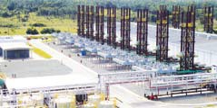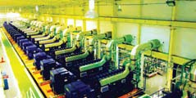300 MW Global I&II, Brazil (HiMSEN 9H25/33 x 120)
- 148 MW Camacari, Brazil (HiMSEN 9H25/33 x 60)

40/52
Global Leader
ENGINE POWER PLANT
HHI Engine & Machinery Division
Global Leader
41/52
HHI Engine & Machinery Division
ENGINE POWER PLANT

Packaged Power Station
Applications
•Captive power
•Construction sites
•Isolated areas
•Rental business
•Pumping stations
•Independent power producers

Prime Mover: HiMSEN Engine
HHI-EMD has developed the Packaged Power Station using HiMSEN engines for captive power such as those used in factories, shopping malls, hotels, rental businesses and so on.
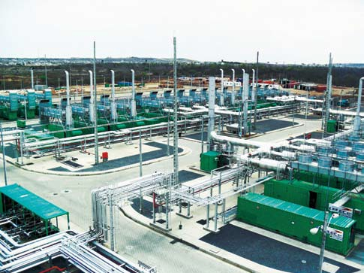The Packaged Power Station, a result of HHI-EMD's creative and technological prowess, will bring contentment to power customers.
1

Engine 6H21/32 |  | 8H21/32 9H21/32
Engine (kW) | 1,200 | 1,600 | 1,800
Generator (kW) | 1,128 | 1,504 | 1,701
Total Weight (ton) | 42 | 48 | 50
Dimension (W x H x L) | 2.4 m × 3.4 m × 12 m (Container Size)
Cooling Method | Radiator / Cooling Tower
Speed | 900 rpm / 1,000 rpm
Fuel | Diesel oil / Heavy fuel oil

2
3

❶ Engine

an
❷ Generator
❸ Control Panel
❹ Enclosure
❺ Radiator
❻ Exhaust Gas Silencer
❼ Ventilation Air Exhaust F

Key Features & Benefits

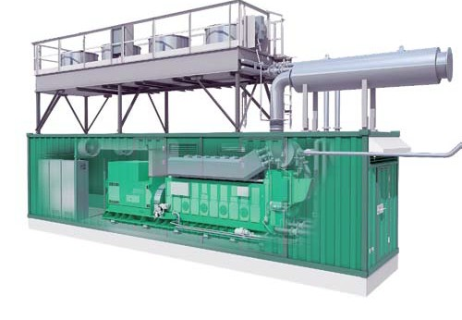•Base load operation
❺
❻
❼
❸
❷
❶
❹
•Diesel oil / heavy fuel oil / natural gas use
•Compact 40-feet container size

•Mobile type (optional)
•Environmentally comfortable
•Low operation and maintenance cost

- 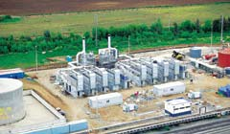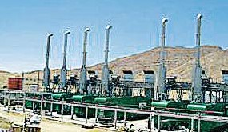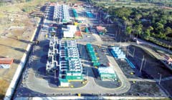Santa-Elena 90 MW PPS in Ecua- dor (HYUNDAI-HiMSEN
4
5
9H21/32 x 53 Sets)
- Puerto-principe 34 MW PPS in Hitai (HYUNDAI-HiMSEN 9H21/32 x 20 Sets)
- BioBio 13.6 MW PPS in Chile (HYUNDAI-HiMSEN
9H21/32 x 8 Sets)
- Namibia 10 MW PPS in Namibia (HYUNDAI-HiMSEN
9H21/32 x 6 Sets)
- 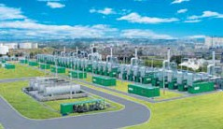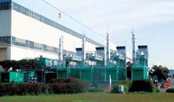Masaya 61 MW PPS in Nicaragua(HYUNDAI-HiMSEN 9H21/32 x 36 Sets)
6
7
- REGLA 47.6MW Packaged Power Station in Cuba (HYUNDAI-HiMSEN 9H21/32 x 28 Sets)
- J-Project 5.6 MW PPS in Japan (HYUNDAI-HiMSEN
9H21/32 x 4 Sets)

HHI-EMD PRODUCTION CAPABILITIES

PRODUCTION FACILITY RESEARCH & DEVELOPMENT CUSTOMER SERVICE GLOBAL NETWORK
CONTACT US

44/52
Global Leader
PRODUCTION FACILITY
HHI Engine & Machinery Division
Global Leader
45/52
HHI Engine & Machinery Division
PRODUCTION FACILITY

Foundry Shop Machining Shop & Assembly-Test Shop

Foundry Shop The Foundry Shop can produce 66,000 tons of castings annually. The modern melting facilities include a 24-ton and a 20-ton medium-frequency induction furnace to produce various kinds of castings.
To produce the best and reliable quality products, the Foundry Shop is equipped with computerized facilities that allow an integrated production control system ranging from raw materials to machining, assembling and testing.

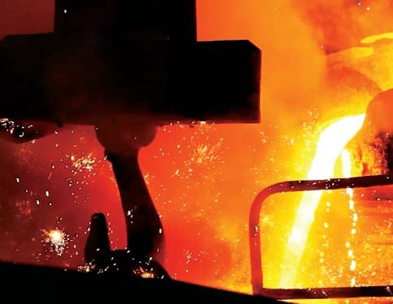
1

2
3

- 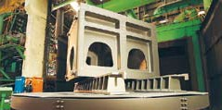Induction Furnace
- Pouring
- Shot Blast Machine

Machining Shop HHI-EMD’s Machining Shop is equipped with over 185 sets of machine tools including up-to-date computerized and numerically controlled machines.
Our CAD/CAM system provides technical assistance so that any kind of high precision products can be made in response to various customer requirements.

Major Facilities
•CNC: ab. 250 Sets
•Plano Miller: 40 Sets
•Horizontal Boring M/C: 50 Sets
•Lathe: 70 Sets
•Grinding M/C: 10 Sets

Machining Shop

- Machining Shop
- Machining of Cylinder Frame
- Cross Head Pin
- Cylinder Cover
- Cylinder Liner
- Intermediate Shaft

Assembly & Test Shop

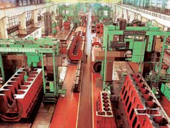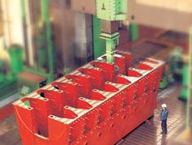
1
2

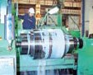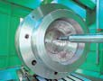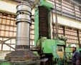
3 4
5 6

2-stroke Engine Assembly & Test Shop
•HYUNDAI-MDT
•HYUNDAI-WinGD

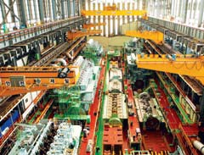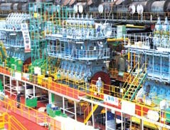

4-stroke Engine Assembly & Test Shop
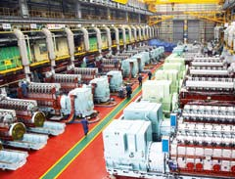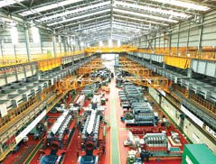•HYUNDAI-HiMSEN

46/52
Global Leader
RESEARCH & DEVELOPMENT
HHI Engine & Machinery Division
Global Leader
47/52
HHI Engine & Machinery Division
RESEARCH & DEVELOPMENT

Quality Management Research & Development

HHI-EMD’s Quality Management System
HHI-EMD has established the quality management policy to consistently provide products and services that meet regulatory requirements and our clients’ needs. We will carry out this policy by:
•Minimizing the quality failure cost.
•Establishing the standardization of design and production.
•Setting up a cooperative system for quality control.

HHI-EMD complies with the Quality Management System (ISO 9001/KS A9001) in accordance with international quality standards and conducts thorough quality inspection over entire process with international classification societies and authorized inspection agencies.

Approval Status of Quality Management System
Product or Service Ranges | Certifying Agency
Design and Manufacture of Two-stroke Diesel Engines, Four-stroke Diesel Engines, | ISO 9001:2000,
 | KS A 9001:2001
Marine Propellers, Pumps & Valves, Press, Conveyor, Robots for Industrial Purposes, | ISO 14001:2004,
Steam Turbine, Gas Turbine, Diesel Power Plants and Engine Components including | KS A 14001:2004
Turbochargers, Crankshafts, Cylinder Liners, Forged Steel, Shafting | OHSAS 18001:1999
 | (DNV)
Nuclear Diesel Generator (Class 1E), Pump and Butterfly Valve | Qualification Approval (KEPIC)
Forging Shop | Works Approval
Casting Shop
Propeller | (ABS, BV, CCS,  DNV, GL, KR, LR,
Semi built-up Crankshaft | NK, RINA)
Solid Crankshaft (TR Forging Crankshaft)
Welding Workshop & Overlay Welding on Cylinder Cover | Works Approval(GL)

Research & Development
HHI’s commitment to research and development (R&D) creates advanced products and services for our clients by focusing on the development of market-driven technology.
HHI-EMD is technologically supported from HHI’s Corporate Research Center and other business research institutes to answer owners’ specific needs in the market.

HHI’s R&D Organization comprises of: Corporate Research Center
•Advanced Technology Research Institute
•Energy System Research Institute
•Convergence Technology Research Institute

Business Division Research Institutes
•Maritime Research Institute (HMRI)
•Engine Research Institute
•Electro-Electric Systems Research Institute
•Construction Equipment Research Institute
•Green Energy Research Institute
•Robotics Research Institute

HMRI(Hyundai Maritime Research Institute)
•Ship Powering/Navigation Performance
•Optimum Hull Form Development & Propulsion
•Seakeeping & Maneuvering
•Ship & Offshore Hydrodynamics
•New Types of LNG Cargo Containment Systems

Engine Research Institute
•Engine Performance
•Product Reliability
•Cooling and Lubricating System
•CHP System
•Intelligent Control & Diagnostic System

Advanced Technology Research Institute
•Development of Welding Process and Equipment
•Material Process Design and Corrosion Management
•Design and Analysis for Steel/Concrete Structures
•Computer-Aided Design for Manufacturing Process
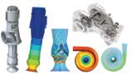•Development of Coating/Automatic Painting Systems

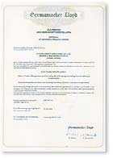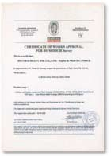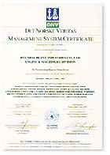
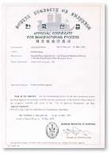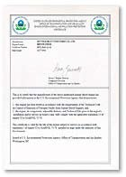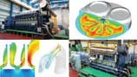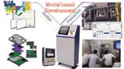

48/52
Global Leader
CUSTOMER SERVICE
HHI Engine & Machinery Division
Global Leader
49/52
HHI Engine & Machinery Division
CUSTOMER SERVICE

Hyundai Global Service HiMSEN Global Academy

Hyundai Global Service Co.,Ltd
Total Solution Provider, One Stop Service
HHI is set to embark on a new journey by setting up an integrated A/S unit to fulfill after-sales needs for shipbuilding, engine and marine electric products.
The new entity named “Hyundai Global Service Co.,Ltd” is launched in Dec. 2016.
Hyundai Global Service will not only provide marine parts to keep your vessels up and running, but also offer technical support to maintain and improve the vessel performance based on accumulated data.
Moreover, the company seeks to establish a prompt A/S system and deliver eco-friendly services by harnessing state-of-the-art ICT, to encourage our clients to come back for repurchase. In particular, Hyundai Global Service will leverage on the proprietary supply chain of its parent company so it can provide one-stop services and total solutions.
By launching the new entity, the right of service business including global service network of Hyundai Heavy Industries Co.,Ltd (HHI) is authorized to Hyundai Global Service Co.,Ltd (HGS)
HiMSEN Global Academy of Hyundai Global Service offers tailored programs that train HiMSEN engine operators and maintenance staff to support safe operation in ships and power plants.
We run learning courses and hands-on training programs about fuctions of main components, engine operation and maintenance, electrical systems and control systems.
We promise that you will learn everything about our HiMSEN engines when you complete courses of HiMSEN Global Academy. For more information, please contact Hyundai Global Service through our email “service@hyundai-gs.com” or “sales@hyundai-gs.com”.

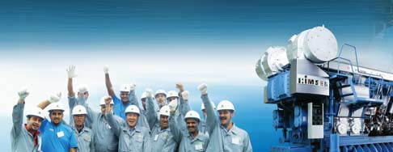Anywhere, Anytime, for Any Matters
HiMSEN Engine has a dream to sail all over the world, with its customers.
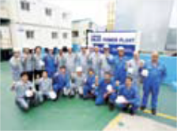Hyundai Global Service can identify, monitor, track and solve your technical problems through its integrated services and supports.

Easy Access to Service
Hyundai Global Service helps clients extend the life of their ships during or even after the warranty period. Our one-stop service center ensures that your Hyundai ships and engines are repaired and upgraded to meet industry standards throughout its entire lifespan.

Genuine Spare Parts Service
VISION
Hyundai Global Service provides a rapid and reliable supply of spare parts at a competitive price throughout the lifespan of your ships. Just contact Hyundai Global Service to find right parts in time for your ships.
Customer
Satisfaction Maximization
Brand-value
Improvement
High-level
Workforce Development
Technical Education
Technical Synergy Creation
Engineer Training Management
Human Exchange Activation
Customer- Oriented Manual Optimization
Diagnosis on Durability & Quality Maintenance Period
Prevention on Problem

Technical Support Service
Hyundai Global Service provides quick and effective technical assistance and technical consultancy for ships and all ranges of engines. With over 40 years of experience in shipbuilding industry, we know every corner of your ship and provide technical support tailored to your needs.

Global Service Network
Hyundai Global Service is networked with service bases in Rotterdam, Dubai, Singapore, Houston and Athens, delivering prompt solutions and comprehensive services for the benefit of our clients around the world.

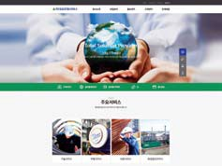

50/52
Global Leader
GLOBAL NETWORK
HHI Engine & Machinery Division
Global Leader
51/52
HHI Engine & Machinery Division
CONTACT US

Global Network
Contact Us

:LY]PJL :[H[PVU

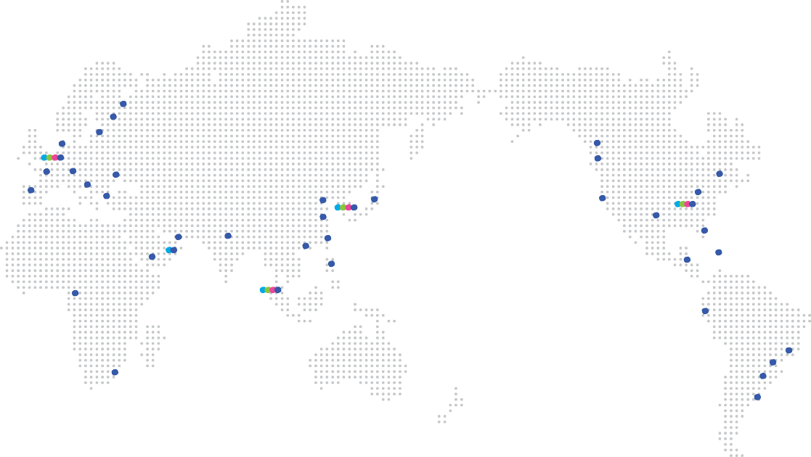:WHYL 7HY[Z +LWV[

:WHYL 7HY[Z +LHSLY (\[OVYPaLK 9LWHPYLY

Marine Engine & Machinery

Marine Engine & Machinery Sales Department
1000, Bangeojinsunhwan-doro, Dong-gu, Ulsan, Korea (Zip Code: 44032) Tel: +82.52.202.7281/7291 | E-mail: eningesales@hhi.co.kr

>PSOLSTZOH]LU 9V[[LYKHT
(U[^LYW

:HPU[ 7L[LYZI\YN
;HSSPUU 2SHPWLKH

3H :WLaPH
0Z[HUI\S

@VRVOHTH

:\YYL`
:LH[[SL

4VU[YLHS

HiMSEN Propulsion System

HiMSEN Propulsion Systemt Department
1000, Bangeojinsunhwan-doro, Dong-gu,Ulsan, Korea (Zip Code : 44032) Tel : +82.52.202.7293
E-mail : k110@hhi.co.kr

*HU[HIYPH
5HWVSP

*`WY\Z

-\QHPYHO 5L^ +LSOP
8PUNKHV
:OHUNOHP

)\ZHU
3VZ (UNLSLZ

;L_HZ
/\TISL
/V\Z[VU

4PHTP
Power Plant Engine Power Plant Sales Department
1000, Bangeojinsunhwan-doro, Dong-gu, Ulsan, Korea (Zip Code: 44032)
Tel: +82.52.202.7301~10

3HNVZ
9P`HKO +\IHP
:OLUaOLU

:PUNHWVYL
2HVOZP\UN

;HN\PN

5PJHYHN\H

,J\HKVY
:HU[V +VTPUNV

9PV +L 1HULPYV
:HV 7HVSV
E-mail: k120hhi@hhi.co.kr

Customer Service Hyundai Global Service Co. Ltd
Centum Science Park 6F 79, Centum jungang-ro, Haeundae-gu, Busan, Korea (Zip code : 48058)

+\YIHU
:HU[VZ
)\LUVZ (PYLZ
Warranty Service
Tel: +82.52.204.7760 (2-stroke Marine)
+82.52.204.7887 (4-stroke Marine)
+82.52.204.7742 (Stationary) Fax:+82.52.204.7801
E-Mail: service@hyundai-gs.com
Parts Sales
Tel: +82.52.204.7718 (2-stroke and 4-stroke Marine)
+82.52.204.7742 (Stationary) Fax:+82.52.204.7700
E-Mail: sales@hyundai-gs.com

.SVIHS 3LHKLY
^^^.OOP.JV.RY

*VW`YPNO[ Ƶ 2018 /`\UKHP /LH]` 0UK\Z[YPLZ
1\UL 2018. *VU[LU[Z Z\IQLJ[ [V JOHUNL ^P[OV\[ WYPVY UV[PJL.



